**Goal**: To implement RYU controller application for gathering network topology information.

objective is to create a RYU topology application that can learn the network topology you created using Mininet API

Starting the topology…

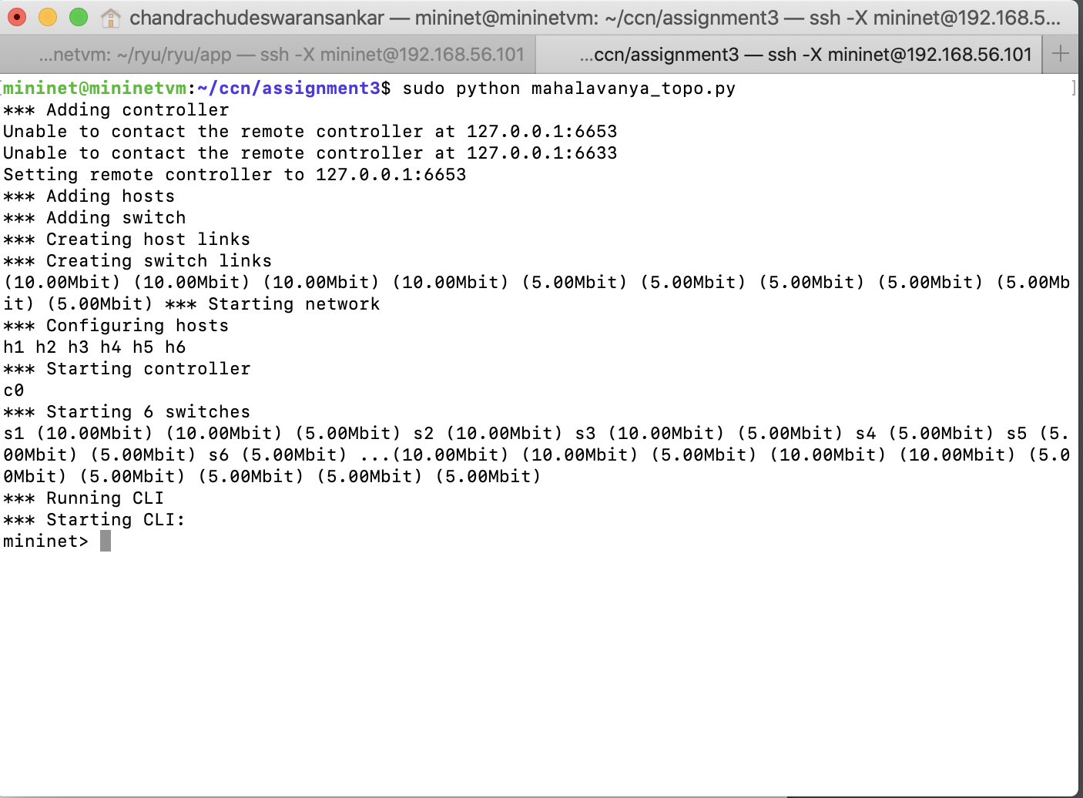

Starting the Ryu controller…

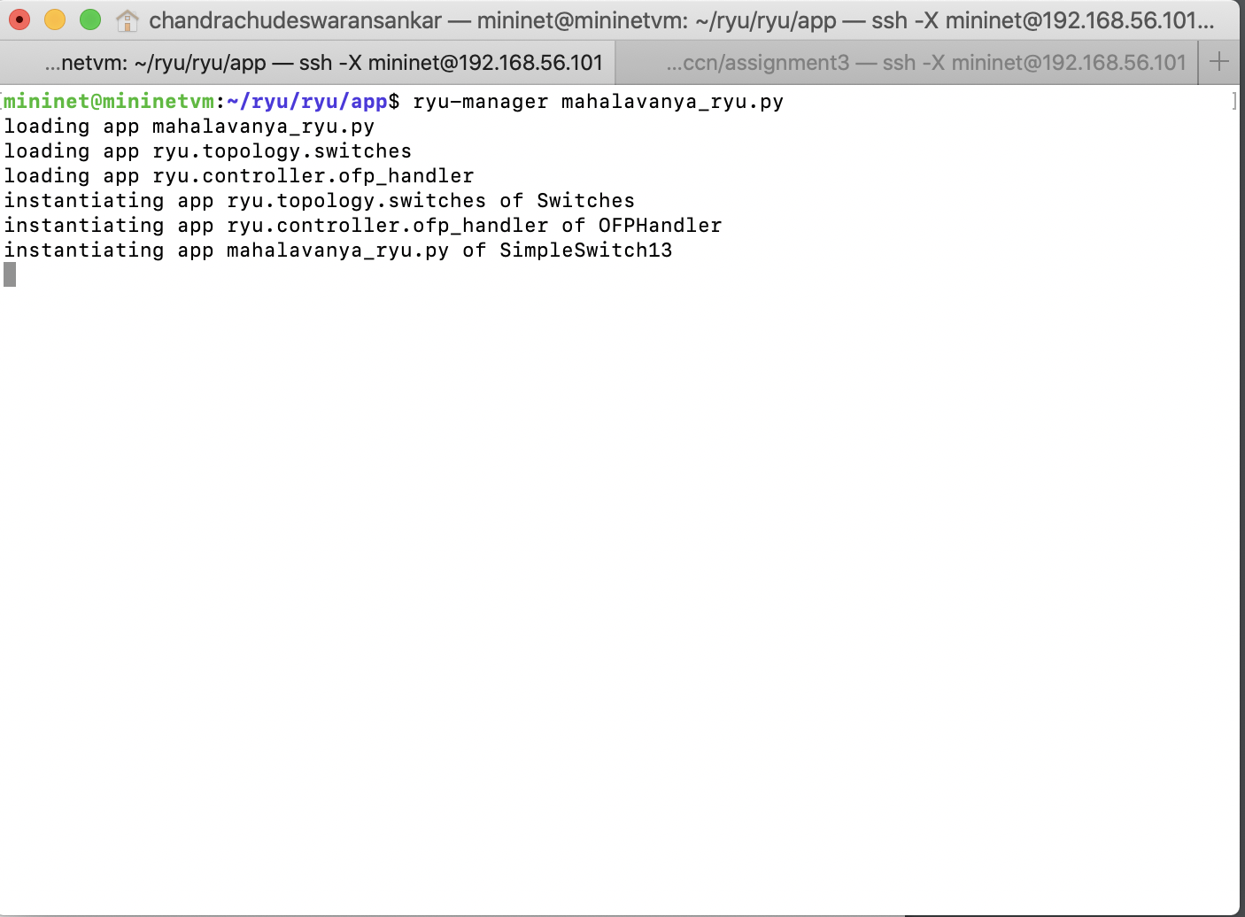

Ryu controller before ping all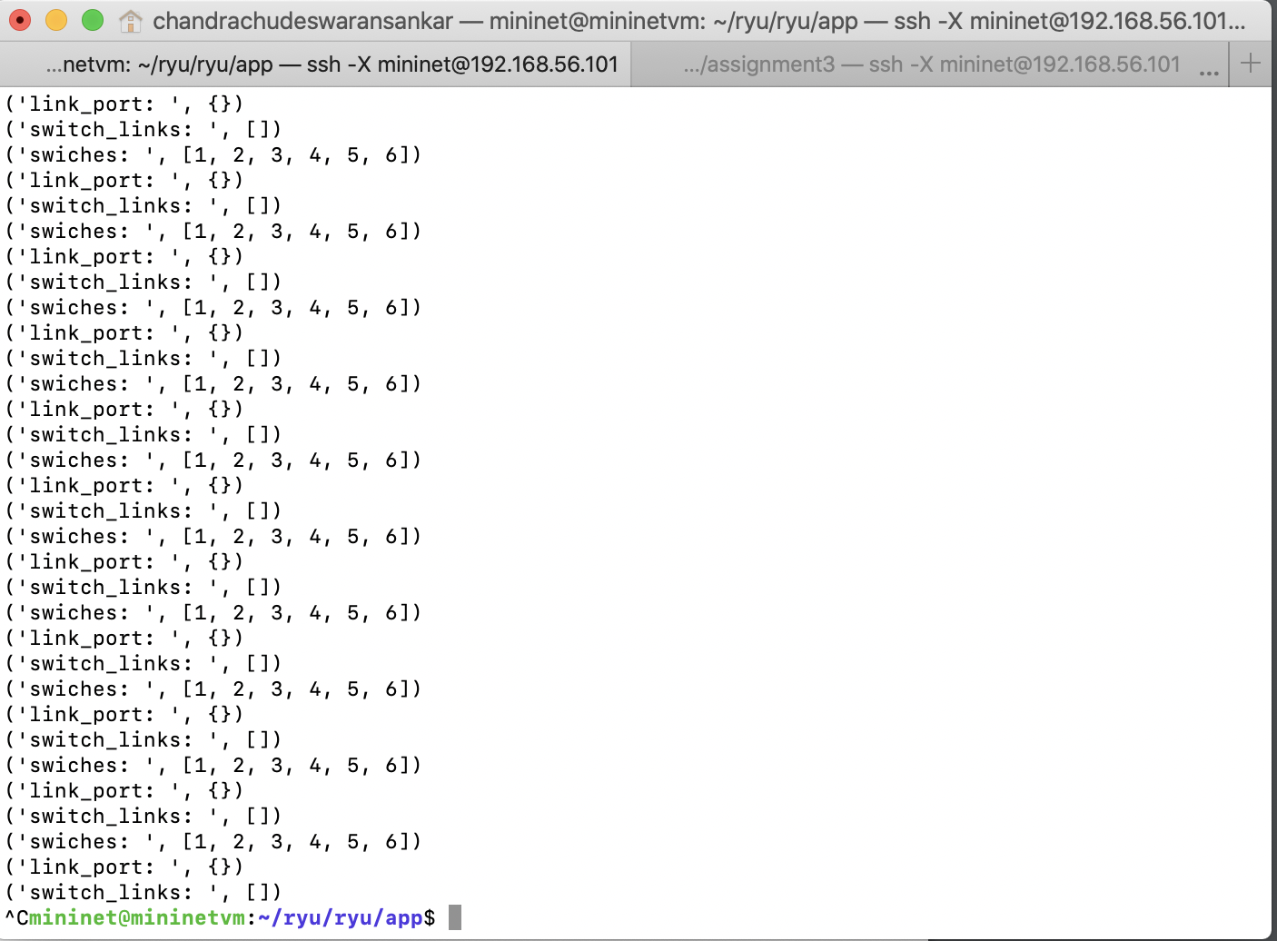

Pingall…

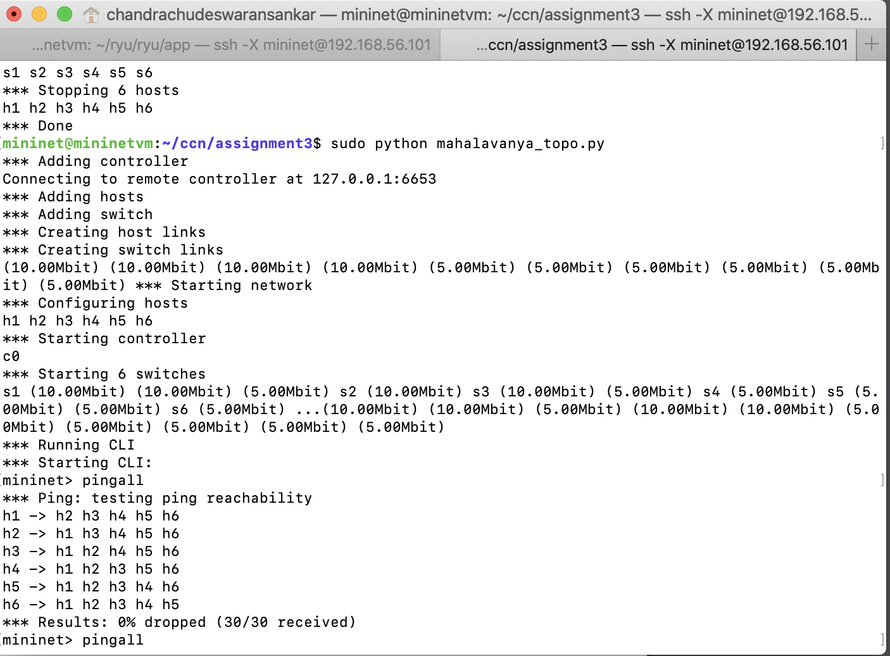

RYU on learning link information

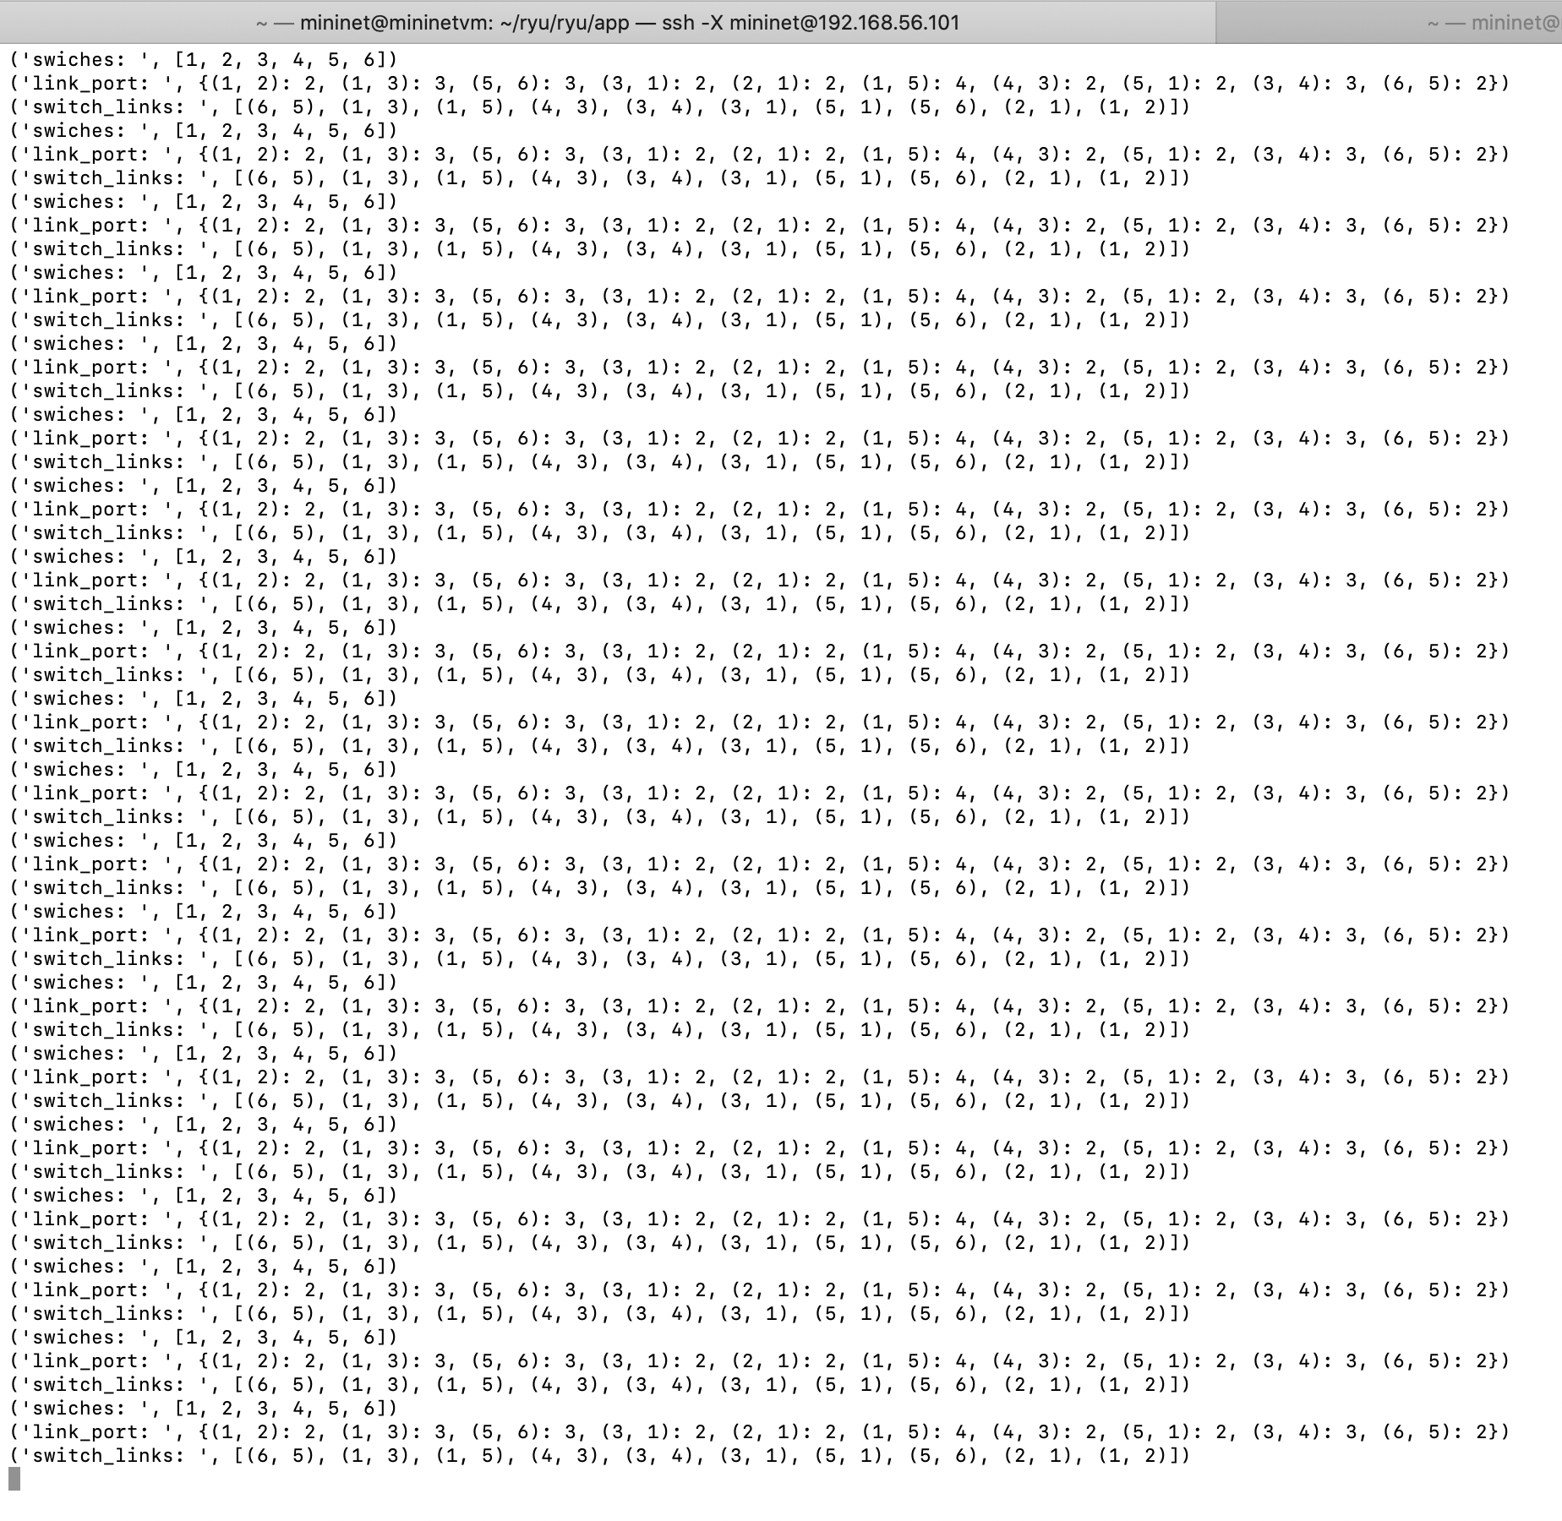

Topology information along with host

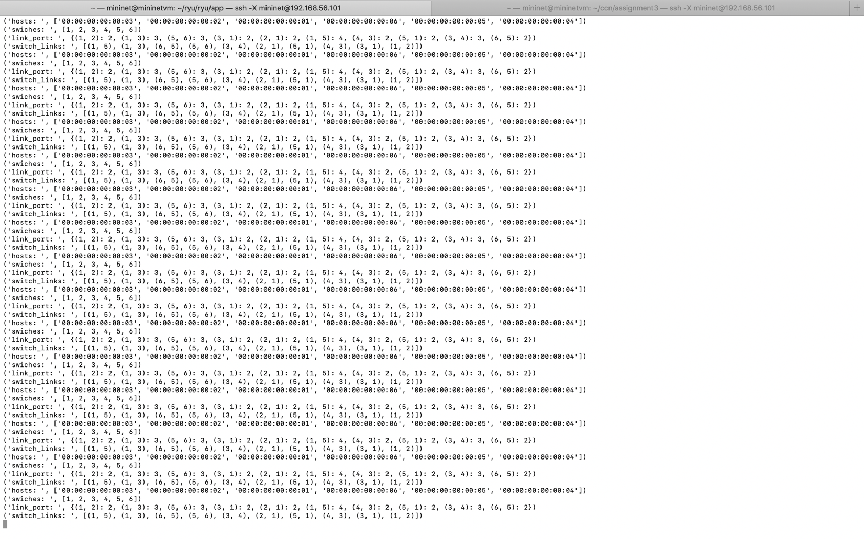

Running iperf server…

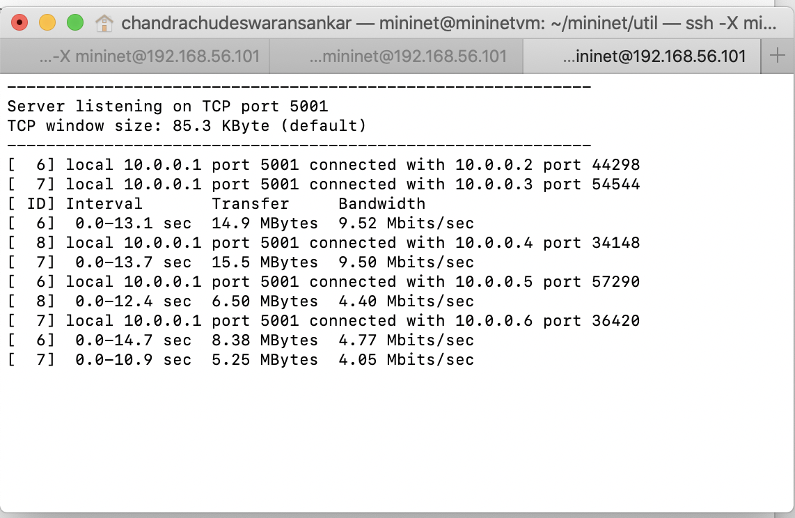

Link cost calculation

